Subcontract Management Fee Policy 2017/18 - June 2017
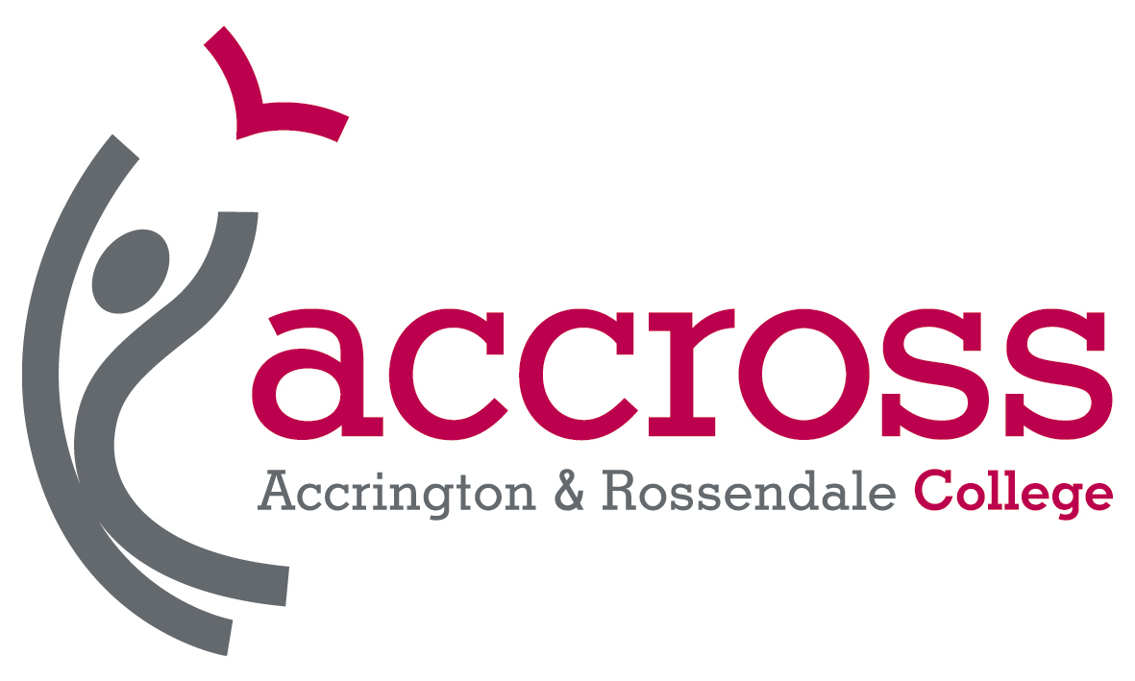

Scope
This policy statement details how Accrington and Rossendale College will apply fees and charges to contracts with organisations subcontracted to deliver training and education on the College’s behalf. This Policy applies to all courses offered by subcontractors of the College, as listed on the ‘Declaration of Subcontractors’, where the subcontractor delivers the full programme of framework.
This document outlines the College’s Supply Chain Charges and Fees Policy for the 2017/18 academic year.

Purpose
The aim of the policy is to provide accurate transparent and comprehensive information to external agencies on the fee policy that Accrington and Rossendale College adopts when subcontracting its provision. This policy is published in line with Education & Skills Funding Agency requirements as stated in the funding rules 2016/17. The policy will be discussed with potential subcontractors during the negotiation of any new contracts.

Disclaimer

The College reserves the right to amend its subcontracting arrangements at any time in accordance with the terms and conditions contained in its standard contract for subcontracted provision.

Overarching Principle

The College will use its supply chains to optimise the impact and effectiveness of service delivery to the end user. The college will therefore ensure that:

Supply chain management activities comply with the principles of best practice in the skills sector. In particular they will be guided by the principles given in the LSIS publication “Supply Chain Management – a good practice guide for the post-16 skills sector” Nov 2012

The College will at all times undertake fair and transparent procurement activities, conducting robust due diligence procedures on potential subcontractors to ensure compliance with the Common Accord at all levels and to ensure the highest quality of learning delivery is made available, demonstrating value for money and a positive impact on learner lives.

The funding that is retained by the College will be related to the costs of the services provided and the risks associated with the subcontractor meeting the standards required by the College. These services, and the levels of funding being retained, will be clearly documented and agreed by all parties. The rates of such retained funding will be commercially viable for both sides and will be negotiated and agreed in a fair and transparent manner. They will be proportionate to the actual services being provided.

Where disputes between supply chain partners cannot be resolved through mutually agreed internal resolution procedures, the College will submit to independent outside arbitration or mediation and abide by its findings. Contract documents will require both parties to agree that the achievements of supply chains are attained through adherence to both the letter and spirit of contracts or partnerships. Signatories therefore commit that all discussions, communications, negotiations and actions undertaken to build, maintain and develop supply chains will be conducted in good faith in accordance with the Overarching Principle.

Rationale for Subcontracting

Subcontracting enables the College to deliver high quality niche provision in areas where subcontractors’ have extensive and focused specialist experience.

Subcontracting ensures cost effectiveness of programme delivery on occasions when it may be desirable for the College to run certain programmes but it is not viable for the College to build up in-house resources and expertise.

Subcontracting contributes towards the sustainability of the College’s provision overall, as it helps the College to respond flexibly to changing market demands and emergent opportunities.

Subcontracting widens the range of progression opportunities for learners, both from Subcontractors’ to the College’s programmes and vice versa.

Subcontracting enables the College to widen participation and increase flexibility and access to education and training at home or in the workplace.

Subcontracting provides good development opportunities for both the College and its Subcontractors, to share good practice and new ways of working.
Upon commencement of the subcontracting process,
Accrington and Rosendale College will consider that the proposed subcontracting arrangement will be in the best interests of all parties.
We will ensure that:
- The proposed delivery is in the best interests of learners and employers and adds value to the work of the College
- The proposed delivery has a clear strategic fit with our mission, objectives and values
- There is sufficient expertise within the College to quality assure the provision
- There is sufficient staff resource in support areas to administer the processes and make alternative arrangements in the event of subcontractor failure to ensure learners are not disadvantaged
- The Subcontractor is approved by our due-diligence process
- There is sufficient funding available within our funding contract
- The Subcontractor agrees to work within the terms of our contract and is willing to engage in a mutually supportive relationship built on trust and respect

Improving the Quality of Teaching and Learning
Subcontracted partners will be expected to meet Accrington and Rossendale College’s quality assurance standards. The College is committed to supporting, developing and sharing good practice and professional development of staff through quality reviews, operational meetings, observations of teaching, learning and assessment and stakeholder feedback.
Subcontracted activity is a fundamental part of Accrington and Rossendale College’s provision. The quality of the provision will be monitored and managed through our existing quality improvement process with the College’s Self-Assessment Report / Quality Improvement Plan process ensuring continuous improvement in all parts of the learner journey. The College will also regularly review External Moderator reports and monitor the implementation of any required actions.
Fees retained by the College

The management fee retained by the College is calculated as a percentage of the total contract value agreed with the Subcontractor. The typical percentage range of fees retained by the College to manage Subcontractors is 10% to 30%.

The management fee is calculated using risk assessment of the following factors.

- Track record of the Subcontractor with regard to meeting success and funding targets.
- The type of provision to be undertaken
- Length and history of previous contract relationship with the College.
- Financial standing of the Subcontractor.
- Anticipated demands of the contract on the College’s resources.
- Contract size with regard to both funding and learner numbers.
- Learner fees
The management fee is open to negotiation and review by Subcontractors subject to reference to specified criteria. The final fee is agreed by both parties and is dependent upon the level of support required, the experience of the Subcontractor, their target learners; their track record, published success rates and the level of risk as determined by the due diligence process.
Support for Subcontractors
The exact mix and level of support for each Subcontractor will vary depending on the needs of the individual Subcontractor. However, all partners will receive a high level of support and guidance and access to College systems, including:
- Quality management systems
- Certification and registration with awarding bodies if required
- Management Information Services and data control advice
- Audit of management systems and delivery and observation of teaching, learning and assessment
- Safeguarding of Young People and Vulnerable Adults procedures
- Health and Safety compliance
- Teaching, Learning and Assessment observations and coaching
- CPD Opportunities, training and development
- Policy development
- Support with Funding Rules compliance
- Regular national updates regarding funding and policy guidance
- Equality and diversity support

Payment Terms between the College and its Subcontractors

Payments from the College to the sub-contractor will be paid upon invoice from the sub-contractor to the College at intervals stated in the contract. Payments will be made by BACS.
Payment will be made to the sub-contractor on satisfactory completion of the learning programme, and on submission of all required documentation in accordance with the requirements set by the Education and Skills Funding Agency Audit, and detailed in the Audit Compliance Guidelines, and any subsequent additions and amendments and following validation of the evidence in the ILR return. The College will make the appropriate payment to the Subcontractor based on the level of income calculated by the validation process less the agreed management fee.

Accrington and Rosendale College expects that the Subcontractors will fully engage in the assessment of accuracy of payments and they therefore have the responsibility to review their remittances to identify any inaccuracies.

ESFA Approval

For 2017/18, the College is unable to enter into any new subcontracting arrangements without prior approval from the Education and Skills Funding Agency.

Supply Chain Fees- Risk Banding framework
(% of contract value) | Costs | Charges
Rationale | Services & support provided within fee | Additional services (additional fees may apply)
Low risk (10-15%)  - Established partner with minimum 3 years relationship  - Contract minimum of 10% of total sub-contracted allocation  - Provision meets priority needs of Education and Skills Funding Agency or local community  - High success rates comparable with College targets  - High cost of delivery  - Delivery close proximity | - Annual contract review and planning meeting. The meeting will include the following agenda items:  - Self-assessment review  - Development plan update  - Review of key performance indicators.  - Feedback from quality audits and stakeholders  - Due diligence update  - CPD  - College update on strategic priorities  - Contract review.  - Regular monitoring meetings (telephone / face to face)  - Registration support (unless agreed otherwise)  - Training and support on administrative process, systems and paperwork  - Timely records, payments , invoicing arrangements  - Single point of contact for queries etc  - Access to Safeguarding / Equality & Diversity training and materials  - Training and support in best practice in teaching, learning and assessment. | - Exam registration  - Internal Verification services  - Liaison with External Verification  - Exam centre registration  - Purchase of resources
Medium risk (20%)
- Established partner with minimum 2 years relationship
- Contract minimum of 5% of total sub-contracted provision
- Provision meets priority needs of local / community or sector priorities
- High success rates comparable with College targets
- Medium cost of delivery
High risk (25-30%)
- New partner, or partner with less than 2 years relationship
- Limited experience of partner in delivering education and training
- Low contract value
- New provision, or provision with higher risks (eg ESOL, NEETS)
- Success rates below College targets
- Low cost of delivery
- Delivery at distance

This policy is reviewed annually and made available on the College website. This policy was approved by our Governing Body on 29th June 2017 and is due for review in July 2018.
As required by the Education and Skills Funding Agency Funding Guidance 2016/17, the information relating to the actual fees and charges relating to subcontracting arrangements in 2016/17 is required to be published alongside the fee policy. This is available on the college website.

