Name Course Tutor Saima Rahna
All About Me
Identify some of your own personal skills and qualities
My Skills.
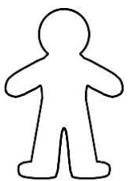
A skill is something you have learnt, for example if you are good at maths/drawing. Think about your skills, can you write a different skill you have in each of the blue boxes? And explain why each skill is important.
Quality –
Why is it beneficial -
Quality –
Why is it beneficial -
Quality –
Why is it beneficial -
Quality –
Why is it beneficial -
Quality –
Why is it beneficial -
Skill –
Why is it important -
Skill –
Why is it important -
Skill –
Why is it important -
Skill –
Why is it important -
Skill –
Why is it important -

My Qualities.
A quality is characteristics that you have, for example you might be a good listener or very patient. Can you think of all the different qualities you have and write a different one in each green box? Also why do you think each of the qualities are beneficial.

My Strengths and Qualities
Compliments I have received:

Challenges that I have overcome:

Things that make me unique:

Time I have made others feel happy:

Things I am good at:

What I like about my appearance:

I have helped others by:

What I value the most:

