Hello and welcome to Accrington and Rossendale College. My name is Hafija Ibrahim and I will be teaching you on the Childcare Level 2 course. I have put together some resources linked to Child development for you to start having a look at. As childcare professionals we want what’s best for children, we want to provide them with everything they may need in order for them to grow into bright, confident and joyful adults. To enable us to do this it is extremely important that we understand the process every child goes through.
Child development is one of the first units we will cover as a group. The resources provided below are to help you get thinking. I have provided some useful links below which will help you through discovery learning. ‘The more you read, the more things you will know. The more that you learn, the more places you’ll go’ (Dr. Seuss). Do not hesitate to get in touch have you any questions. I look forward to hearing from you soon.
h.ibrahim@nelson.ac.uk

Child development refers to the sequences of physical, language, thoughts and emotional changes that occur in a child from birth. It is influence by environmental factors and the child’s learning capacity.
Child development covers the full scope of skills that a child masters over their life span including development in:
- Cognition
- Social interaction
- Speech and language
- Physical skills
- Sensory awareness

Task 1: Research the different types of developments mentioned above and provide a brief definition for each area in your own words.

E.g. Cognition- the ability to learn and problem solve

Task 2: The grid shows ages and stages of child development. Complete the grid below (you will need to carry out research before completing this task).

Task 3: You have been given a scenario on each card. Answer the questions asked referring back to the knowledge and understand you have gained on different types of development.

Task 2
 | 0-3 months | 3-6 months | 6-9 months | 9-12 months | 12-18 months | 18 months-2 years | 2 years | 3 years
Physical development

Intellectual/cognitive development
Communication/speech and language | E.g. Crying, smiling, squealing, gurgling
Social and emotional development

Behavioural development

Useful links:
Video:
https://vimeo.com/14227882
https://youtu.be/Tli0mvqlWik (Child Development and Learning
https://youtu.be/uGOPDBGPB1Q (Talking tips for kids: Ages and Stages (Ages 0-5 years old)
Reading:
Childdevelopment.com.au
https://kidshealth.org (Your Child’s Development (Birth to 3 years)
www.psychologytoday.com (Child Development)
www.cdc.gov (Child Development Basics)
https://developingchild.harvard.education (8 Things to Remember about Child Development
https://www.nhsggc.org.uk (Child Development)
https://childdevelopmentinfo.com (Ages and Stages Of Child Development)
www.goodtoknow.co.uk (Child development stages)
https://www.healthline.com (Ages and Stages: How to Monitor Child Development)
Child development theories:
Sigmund Freud 1856- 1939
Jean Piaget 1896- 1980
Lev Vygotsky 1896- 1934
B.F. Skinner 1904- 1990

Task 3 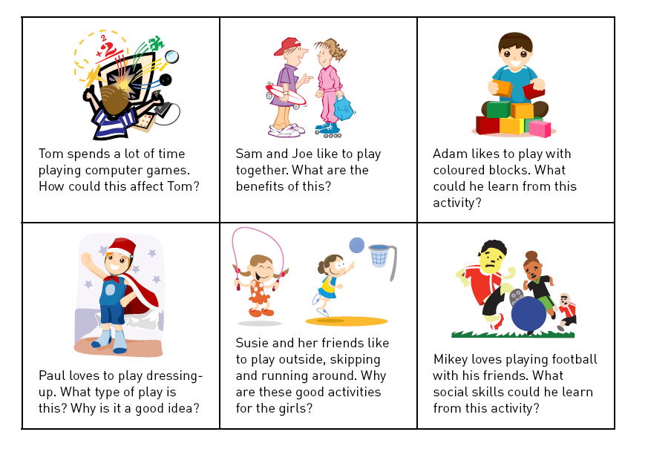

1: Tom:

2: Sam and Jeo:

3. Adam:

4: Paul

5: Susie

6: Mikey

