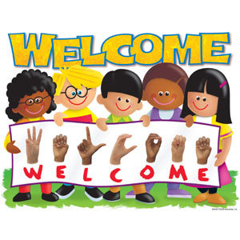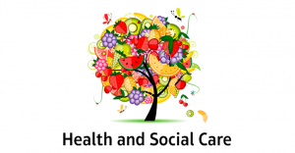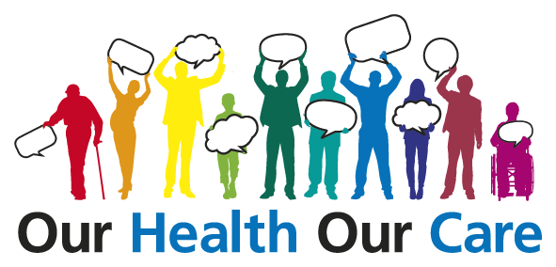

Welcome to the Level 2 study program incorporating Health and Social Care at Nelson and Colne College. My name is Jacqui Ashton a teacher and tutor on the Level 2 program.

We are currently in a situation due Corona virus and the lockdown which is preventing us from contacting you in the ways we would normally. We cannot come to your school to introduce ourselves or invite you to college to attend New Student Days.

As part of the induction process and introduction to the qualification, I have set a task for you to complete. The purpose of this is to enable us to get to know each other a little better and for me to access your abilities. We need to make sure when you enrol at college, you have a study program tailored to meet your specific learning needs. It will also make sure you have a basic understanding of communication in health and social care, a topic we will look at in much more detail.
I look forward to working with you and helping to make your learning experience at Nelson and Colne College a memorable one.

Kind regards

Jacqui Ashton
Homework Activity.
Effective Communication in Health and Social Care

How good are your communication skills?

Clear communication is important to enable service users to understand and agree to the care they are receiving.

Good communication between care professionals allows them to perform their roles effectively, work cooperatively with colleagues and build supportive relationships with service users.

If you have ever used health or social care services, you will have noticed the number of times that the staff communicate with each other and with service users and the many different ways in which they can communicate.

Research task: Investigate different forms of communication

Part 1: Leaflet (Pass Grade).

Gather information about the following;
- Verbal communication
- Non-verbal communication
- Formal communication
- Informal communication
- One-to-one communication
- Group communication
- Alternative forms of Communication

Using the information gathered produce a leaflet to;
- Describe what each of these mean.
- Give an example of a health and social care situation that would use this form of communicating stating why.
- Make your leaflet colourful and factual

Please email me your leaflet, making sure your name and school are clearly visible. j.ashton@nelson.ac.uk

Part 2a: Essay
Barriers stop something from happening. In terms of communication, barriers stop the message you wish to send being received and understood. This can be problematic when supporting people in need. For example, you are asking a service user if they have had their medication but they were unable to hear you properly. The answer to your question was ‘yes’ when in fact they hadn’t. They could become ill or suffer life threatening health issues. This was all because their hearing became a ‘barrier’ to communication.
Barriers can include background noise, poor lighting, foreign language, lack of knowledge, fear, mental illness, aggression, substance misuse, stroke etc.
You need to write an essay explaining what ‘barriers’ can affect the forms of communication you discussed in Part 1. What could go wrong and why? More importantly who will be affected? Use examples. Think of the service users needs, can they hear, are the blind, do they understand English, and do they have a disability or learning need?
Research:
- Forms of communication
- Barriers to and effective communication
- How health and social care professionals communicate effectively at work
- Youtube – Casualty, 999 What’s Your Emergency, 24 Hours in A&E, Holby City etc
Add the URL addresses used for research and information at the end of your essay, (bibliography).
Remember not to copy or cut and paste. Read the information and write in your own words.
Part 2b: Essay continued.
When barriers occur we need to be able to change the method in which we communicated to overcome them. In most instances health and social care professionals will need to think on their feet, changing the way they communicate immediately to get a positive response.
Again looking at the forms of communication used earlier, write an evaluation of why it is important for health and social care practitioners to be able to overcome barriers to communication. Give examples.

Research
- Overcoming barriers to communication
- How to overcome barriers to communication

End your essay with a conclusion that clearly explains what effective communication is, what the barriers to effective communication are and how you can overcome them and finally the importance of being able to communicate effectively in health and social care settings.
Again, add the URL addresses used for research and information at the end of your essay, (bibliography).
Remember not to copy or cut and paste. Read the information and write in your own words.

Please email me your essay, making sure your name and school are clearly visible. j.ashton@nelson.ac.uk

Good Luck
Jacqui Ashton, (HSC Level 2 Teacher).

