Year 11 Preparing for College Hairdressing
Level 1

In this project you are going to complete different tasks that will prepare you for your new hairdressing course in college.

You will have to complete research, projects and watch videos that will help you understand what the course is about.
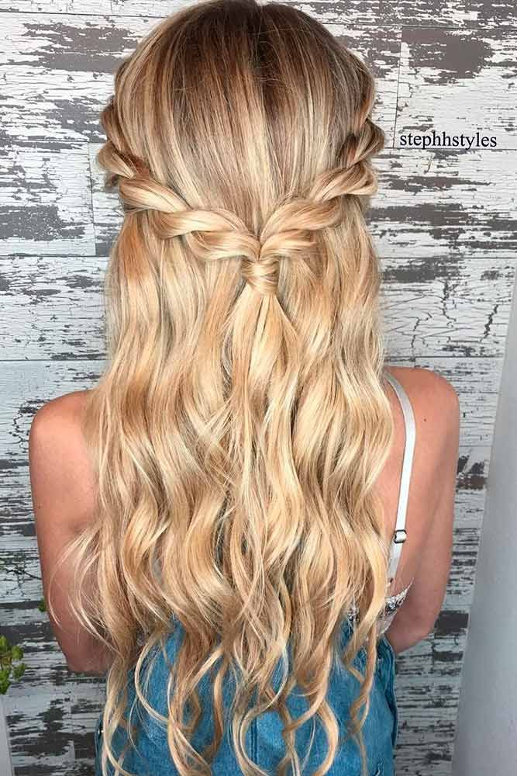

Task one

In this task you will research 5 different salons in your area and produce either a power point or written work if you do not have access to a computer.

- Describe what different kinds of salons are available in your area. Show pictures if possible.
- Identify what kind of people will visit these different salons.
- Identify the different prices that each salon charges.
- Describe the different services that each salon offers.
What kind of salon would you like to work in?

Do I have to work in a salon? Where else can I use my hairdressing skills?

Complete the spider graph below. Add as many job opportunities as you can.

Cruise ships
Hairdressing careers

Task 2
Look at the pictures below and research what you think each item would be used for in hairdressing. Stretch yourself further and describe what effect would be created with the tools and equipment.
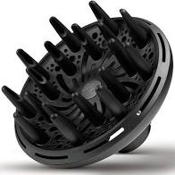
1.

2.

3.

4.

Task 3
What will I learn?
Below are some videos of the services you will learn in year one.
Watch the videos and practise on your mum sister, brother (only someone in your household)
Take pictures or videos

- Plaiting
https://www.youtube.com/watch?v=m2g57cXO-2Q
- Curling
https://www.youtube.com/watch?v=Z8ZS0-qHtBE
- Curly blow dry
https://www.youtube.com/watch?v=xQAwJc1LKOw

Task 4.
Why do you want to be a hairdresser/barber?
Explain why you chose hairdressing/barbering, what inspires you?
Have you any experience of working in a salon?
What do you expect from your college course?
Write a paragraph of approximately 250 words.

Hope to see you all soon in college.

For any Facebook users there are lots of weekly virtual tutorials,
One to watch is Hair socials which has a daily tutorial on different hair techniques

https://www.facebook.com/groups/2502412553355320/

