Subject | Level 1 Business Studies
Qualification | Work Skills
Exam Board / Awarding Body | BTEC

Learning Outcomes
- To be able to understand the different payment methods when making payments online.
- Be able to set up your own PayPal Account for when purchasing online.
- Be Able to recommend a more suitable payment method for when somebody is wanting to purchase goods online.

Task 1 – You are wanting to buy your favourite PlayStation 4 game from EBAY, it costs £40.00 online with free delivery! You decide to buy the game, when it comes to checking out, it gives you an option to pay via bank card or PayPal. What do you think will be the best payment method for this scenario and why?

Place your Answer in this box:

Research:
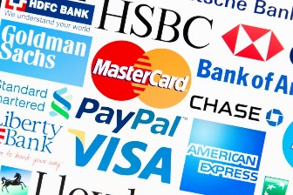
What are the benefits of using PayPal as opposed too using your Bank Card?
What are some of the risks associated with using your Bank card for payments online?
Why do people feel safer using PayPal when purchasing from E – Commerce websites?

Task 2 – Create a word document on the differences between Bank transfer using your card online and using a payment method such as PayPal for purchasing items online.
Place your Answer in this box:

Task 3 – Think about safe storage, do you think your money is more safely secure on your PayPal Account or do you think it would be more secure in your bank account?

Place your Answer in this box:

Email the tasks upon completion to your tutor

