Getting ready for college
Subject | Painting & Decorating
Level | One
Qualification | Certificate in P&D
Exam board / awarding body | NOCN Cskills
Getting ready to study:
- Read – Professional painter & decorator magazines, www.paintinganddecoratingnews.co.uk is a fantastic website that showcases up to date industry news and innovations plus there are many monthly copies of the trade magazine to read in PDF format. These offer the latest information on the trade and there are excellent competitions and prizes to win.
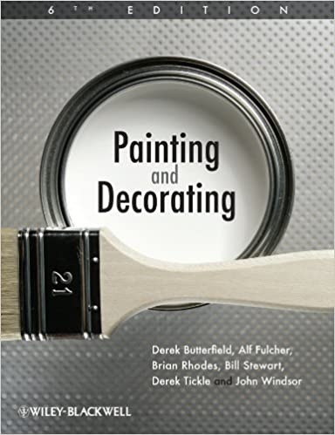 This is the definitive textbook for P&D, it contains everything that a professional decorator will ever need to carry out their work efficiently and to the best standards. It is available for delivery from Amazon.co.uk for £18 used or £23 new. It is essential reading for the course and you will have it to refer to throughout your career – Author is Derek Butterfield, Alf Fulcher et.al
- Watch - https://www.youtube.com/watch?v=bGsdzJmJHrg

https://www.youtube.com/watch?v=3HSuqwi_CY8

https://www.youtube.com/watch?v=s0yzYdPctaE

The YouTube clips above have some good information on how to decorate professionally rather than DIY. You will be taught how to do it the correct way at college and at work by your employer. Remember! There’s more than one way to do it, so you might be shown some techniques that differ from those in the videos. I would also suggest that you find and watch other videos on decorating and make notes, as these can be discussed during theory sessions and debates can be started to critique the content once your course has begun.

- Social Media – Follow Pete Wilkinson (PaintTech Training), Simon Thompson (Thompson Décor), Naomi Parker (Naomi Parker Interiors) and Darren Richards on Facebook. Those guys are out there doing excellent work and regularly post snapshots of their jobs. Some of those guys were trained at Accrington & Rossendale college.

