Getting ready for college
Subject | Website Development
Level | LEVEL 3
Qualification | Extended Diploma in IT/Digital T-level
Exam board / awarding body | BTEC Pearson
Getting ready to study
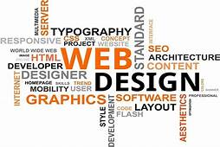
As part of the L3 IT program you will be studying website development.
During your web development lessons you will be introduced to a number of new words and you will need to understand these words and their definitions. To help you get a head start with website development you can research the following terms and come up with definitions.
Please feel free to use a table similar to the one below to document your findings and I look forward to seeing your answers when you join us in the new term.

Leslie Dundas
IT & Computing Lecturer

One suggestion is using the following headings for inspiration:
- Read – Books; Magazines; Newspapers; Periodicals
- Watch – Video; TV; Movie; You Tube
- Listen – Podcast; Radio; Audible
- Get Involved – Competitions; Social Media; Webinar
- Visit – Museums; Galleries; Libraries (only when we are allowed outside again)

Research and list the following web development terms:
Term | Definition | Example
Html
CSS
CMS
SEO
Hosting
Domain Name
Client Side
Server Side

