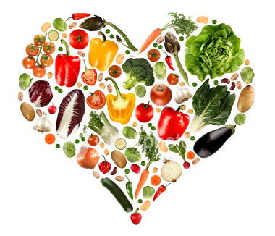
Promoting healthy eating in a Care home

You are a Social Care worker and have started a new job, on your first day at work you realise that the care manager only provides bread and water to the people in his care. This worries you and you are quick to question the owner as to why he does this. The owner tells you that this is because he has people of different needs and is not quite sure how he can create a suitable menu that will meet the needs of people in his care.
You offer to help him and promise that you will research the cultural, religious and health needs of the people in his care and will come up with a menu that will make sure that everyone has access to good healthy food.
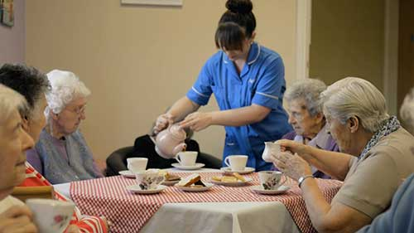

Health and religious needs of people in the care home:
- Karan is a Hindu, he is not vegetarian but is a diabetic.
- Sarah has a dairy and nut allergy
- Lilly is a Vegetarian
- Sui is of Chinese origin and wants to eat more of her native foods
- Mariam is a Muslim so can only eat certain foods
- Thomas is Jewish so needs to have his food prepared in a certain way and is not allowed to eat certain foods.
- Sarah is a Vegan and is quite strict about what she will eat.

Websites to help you:
Food Restrictions http://www.butlersguild.com/index.php?subject=103
NHS website will provide information on Healthy Eating https://www.nhs.uk/live-well/eat-well/

Task 1
What is a heathy and balanced diet?
_______________________________________________________________________________________________________________________________________________________________________________________________________________________________________________________________________________________________________________________________________________________________________________________________________________________________________________________________________

Name the different food groups, with examples of foods in each category:
1
2
3
4
5
What is the recommended amount of water that needs to be consumed in a day?
________________________________________________________________________________________________________

Salt |  | A. Part of a balanced diet, recommendations are for 5 portions a day
Minerals |  | B. Food rich in carbohydrate and fibre – better varieties are wholemeal and wholegrain
Vitamin |  | C. Is used in the body for growth and repair of tissues
Milk |  | D. Good sources of protein and iron
Carbohydrate |  | E. A good source of calcium needed for healthy teeth and bones
Fat |  | F. Is needed to keep the body hydrated
Sugars |  | G. Can consist of fructose, maltose, glucose molecules
Meat |  | H. Organic substances essential for body function but only needed in minute quantities
Fruit and vegetables |  | I. Is used to provide energy for the body but is also stored for insulation
Fibre |  | J. Is a diet that provides all the nutrients necessary for health in sufficient amounts
Balanced diet |  | K. Is used to provide energy in the body
Water |  | L. Small amounts of inorganic substances needed for body function
Protein |  | M. Keeps the digestive system functioning properly to avoid constipation
Bread |  | N. Is important to maintain the balance of internal fluids in the body

Match the words below to the statements that describe them.

Task 2
- You must research the dietary needs of each person and explore what they can and cannot eat.
- You must also provide a brief explanation why certain things cannot be eaten.
- Please make your notes in the table below. You can add images, details of websites to further demonstrate your understanding.
Name | Is this a Health, Cultural or Religious Need? | Research on this dietary need | Food that this individual cannot eat. | Reason why these foods cannot be eaten. | Foods that can be eaten to make sure diet is healthy and balanced
Karan
Sarah
Lilly
Sui
Mariam
Thomas
Sarah

Task 4
You now need to select 2 individuals from the table above and created a weekly diet plan for each individual. You must ensure that this plan meets the individual’s health needs and provides the individual with a healthy and balanced diet.
Individual I am preparing a meal plan for:

Things I need to consider before I make my plan:
Weekly  Meal Plan | Monday | Tuesday | Wednesday | Thursday | Friday | Saturday | Sunday
Breakfast
Lunch
Supper
Snacks and Drinks
Individual I am preparing a meal plan for:

Things I need to consider before I make my plan:
Weekly  Meal Plan | Monday | Tuesday | Wednesday | Thursday | Friday | Saturday | Sunday
Breakfast
Lunch
Supper
Snacks and Drinks

Review of activity

Why is it important to have knowledge and understanding of an individual’s dietary needs when working in Health and Social Care?
____________________________________________________________________________________________________________________________________________________________________________________________________________________________________________________________________________________________________________________________________________________________________________________________________________________________________________________________________________________________________________________________________________________________________________________________________________________________________________________________________________________________________________________________
Can you identify a range of Health and Social Care related careers where you may have some responsibility in meeting the dietary needs of an individual or groups of people:
____________________________________________________________________________________________________________________________________________________________________________________________________________________________________________________________________________________________________________________________________________________________________________________________________________________________________________________________________________________________________________________

