Ref: DM/HT4/Apr25

17th April 2025

Dear Parent/carer

Please find attached your young person’s grades for half term four.

As we approach the final term of the academic year, the grades are indicative of current progress, reflecting their current “working at” grades and employability score / attitude to learning. As well as this you will also see a personal development grade which reports on learners’ wider skills and behaviours. If you have any questions about this report, please contact your young person’s personal tutor in the first instance.

For any other regular updates, information and news, please head to the Parent Zone of our college websites:

For students attending the Accrington & Rossendale College Campus:

<https://www.accross.ac.uk/about-us/parents-zone/>

For students attending the Nelson & Colne College Campus:

<https://www.nelson.ac.uk/about-us/parents-zone/>

Please visit the website regularly to keep up to date.

Yours faithfully Yours faithfully

cid:65b7fbf2-0cf4-414d-9891-835d89215d7e 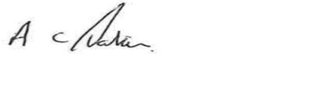

Fionnuala Swann Andrew Parkin

Campus Principal Campus Principal

Nelson & Colne College Accrington & Rossendale College